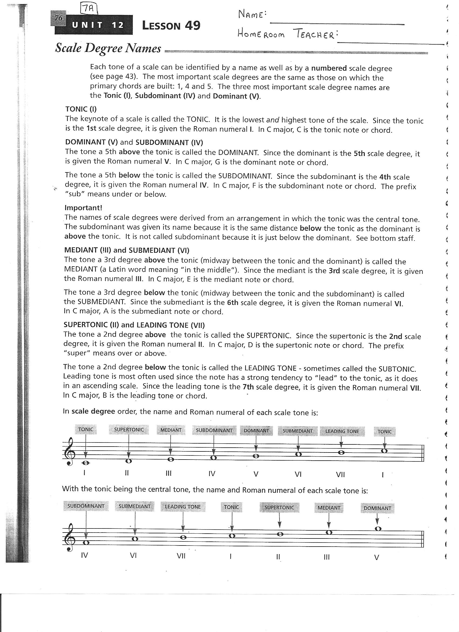
- Write the scale degree for the following Roman numeral tones:
  - III:
  - VII:
  - I:
  - IV:
  - VIII:
  - II:
  - V:
  - VI:

- Write the Roman numeral tone for the following Scale Degrees:
  - Mediant:
  - Supertonic:
  - Leading Tone:
  - Tonic:
  - Subdominant:
  - Submediant:
  - Dominant:

